# Engineering Report

## Introduction

The Hydra 1 experiment hardware design is based on open design of the plant growth ‘Module on Moon’ called the Lunar Green House Module, developed as a Center Innovation Fund study at NASA Ames Research Center in March 2015. Hydra-1 is developed as an Experiment Cube payload to be operated inside the ICE Cubes Facility, on board the Columbus module of the ISS. The experiment duration is approximately 20 days. Payload data from this experiment is primarily periodic high-resolution images of the plants growth and readings from the temperature sensor inside the experiment.

## Experiment Requirements + Limitations

### Requirements for illumination and temperature

Payload electronics were designed to meet the following scientific requirements:

1. The luminosity of the LEDs shall be between 120 and 150 PPFD.
2. The experiment cube temperature shall be between 19 to 25°C.
3. The ratio of red and blue LEDs shall be 2:1. Red and blue LEDs of wavelength ~665 and 430 nm will be used
4. The experiment cube shall have at least one level of containment to seal the plant growth chamber.

### Limitation in terms of plant growth due to limited CO2

The sealed growth chamber had approx. 0.63 liters of volume of air at one atmospheric pressure. As a consequence, the CO2 available for seeds germination was limited (but adequate to support germination and initial growth phases).

The decomposition of the plants is considered not to release toxic products. The death and decomposition of the plants will result in the production of CO2. Each mole of CO2 produced will be associated with a mole of O2 removed from the atmosphere inside the sealed greenhouse. Generically the decomposition of organic matter can be expressed as C.H2O + O2 => CO2 + H2O. Therefore, the total number of gas molecules will not change. Anaerobic production of gases (CO2, CH4) is prevented by the O2 rich atmosphere.

## Interface with ICE Cubes Service

The experiment was installed in the ICE Cubes facility aboard the International Space Station. The ICE Cubes facility can host up to 20 1U cubes. The layout of the facility is as shown in picture below.

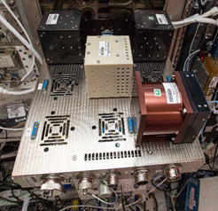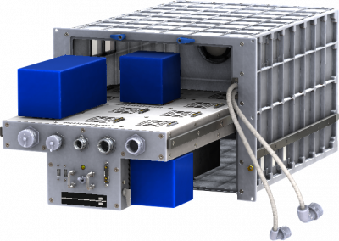

Figure 1a) Hydra 1 Installed in ICE Cubes facility 2b) Layout of the ICF (Image Courtesy: Space Applications Services)

The ICF provides the experiment cubes with up to 10 W of power on 12 V or 5 W power rails. The experiment cubes can also be connected to gigabit Ethernet interface with ICF. The facility itself is cooled using forced air cooling to maintain the temperature between 19°C to 26°C. The cubes are connected to the ICF facility using a DB13W3 connector, which protrudes out of the experiment cube on - Z axis (ICE Cubes Team, 2019).

## Experiment Hardware Overview

### Size of the experiment

Hydra1 is a 1.25 U payload with 1 U of space for plant growth module and 0.25 U of space to house the onboard computer and interface connection to the ICE Cubes facility. The dimensions of the experiment are 10 cm x 10 cm x 12.5 cm and it weighs 1.065 kg.

### Introduction to hardware nomenclature

The hardware developed for the mission can be divided into two modules: The Electronics Box (EB) housing the Raspberry Pi and the Plant Growth Unit. The Electronic Box provides a connection with ICF via a DB12W3 connector, and houses the Raspberry Pi which acts as on-board computer. This module has 10 x 10 x2 .5 cm dimensions and is attached to the Plant Growth Unit (PGU) via eight M2.5 screws. The power and data connections to the electronic components are provided via a welded male nine pin connector on the PGU lid. The hardware components are shown in figure 2 below in an exploded view.

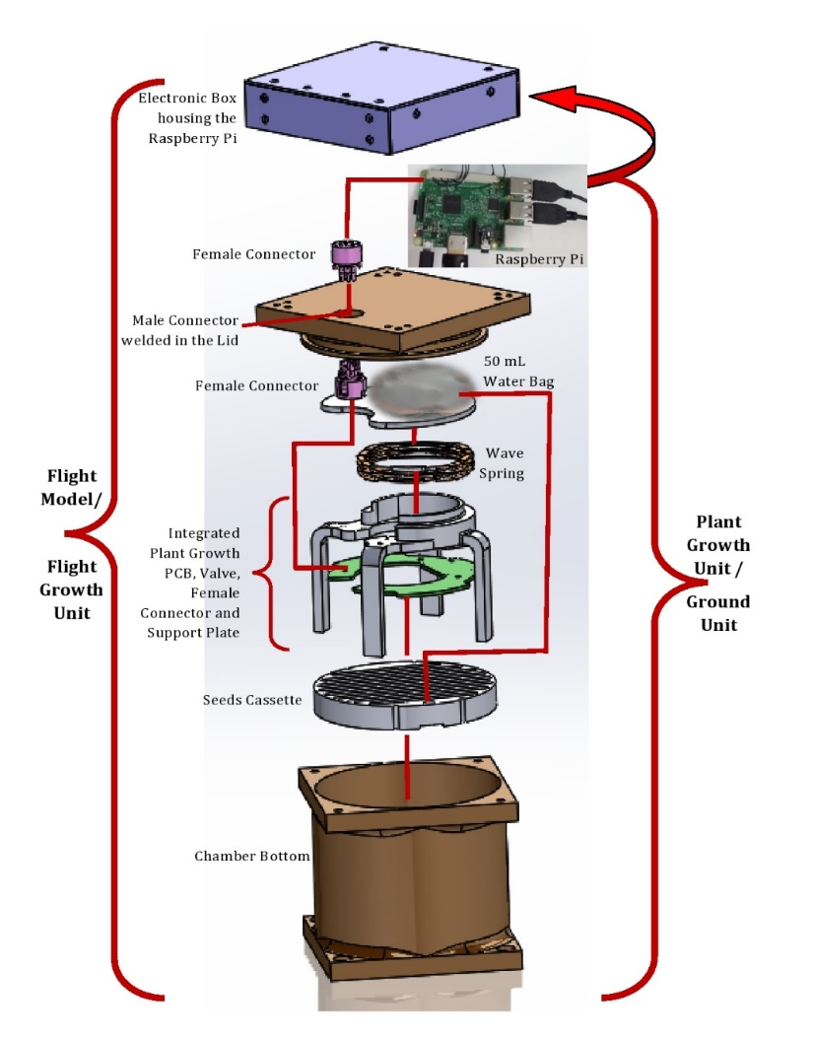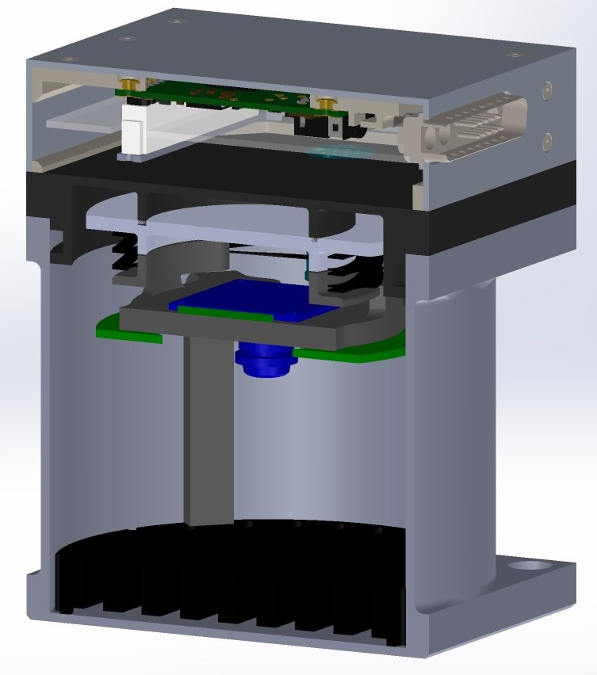

Figure 2a ) Layout of the experiment container 2b) Exploded view of the container

The PGU is built from standard aluminum T6601 alloy for good heat dissipation and temperature control. The plant growth chamber contains all the electronics for the mission, which includes LEDs, a temperature sensor, a camera, and a valve. All the power and data connections for the components are routed through the plant growth printed circuit board (PCB), specially designed for the mission. The PCB was mounted on the support plate using 4 mm M2.5 standoffs. A biocompatible bag contains water and nutrients for the seeds. This water bag is placed on top of a spring plate, and is under constant pressure from the wave spring. The spring pushes the water bag against the lid, once the chamber is closed. A 5MP HD camera is also mounted on the support plate facing towards the seeds cassette. This camera is turned on every 4 hours to take an HD image of the seeds.

The seed cassette is installed in the bottom of the PGU and under the support plate. The cassette is made of aluminum and the seeds are glued to paper in the furrows of the cassette using gum gar. The paper is held together using an aluminum mesh/comb structure. Paper and seeds in the furrow are secured using two aluminum wires wrapped around the seed cassette. These wires secure the paper against vibrations and forces during transportation and launch. The plant growth chamber is sealed using an O-ring and the lid is closed using 4 M3 Screws.

### Different manufacturing techniques to manufacture the hardware for example: Processes involved with electroplating structures

The EB has a 3D printed Polyamide PA2200 housing, with thread-serts inserted in the housing to mount various components. The housing is then painted with conductive silver and then electroplated with Nickel to increase the strength of the casing. The structure is grounded with the ICE Cubes facility. The casing structure is covered on all sides with black anodized aluminum plates, which are chamfered on the sides.

### Water release mechanism:

The experiment relies on a biocompatible water bag which is under pressure from a wave spring. The water bag tubing is connected to a two-way valve. The valve can be activated by command from the ground. Water is released to the see cassette in the orbit. The seed cassette consists of layers of cheese cloth and seeds glued to the paper supported with aluminum mesh in the seed cassette furrows. Once the water is released, absorbent cheese cloth and paper wicks the moisture across the seed cassette. A water indicator is glued on the paper which turns red after exposure to water. This indicator provides a way to confirm water delivery.

## Electronics and Software Overview

The experiment operates using 5V-regulated DC. A Raspberry Pi B v1.1 serves as the on-board computer and it is connected to ICE Cubes facility using a D-sub DB13W3 connector which provides power and Ethernet connection. The flight electronics in the PGU were powered through USB port of the Raspberry Pi.

### Electronics design

The on-board computer is located external to the plant growth chamber where the lights, camera, and valve are located so a connector is used in the lid. A PCB was developed to distribute power and data lines inside of the PGC. One advantage of this design is that it enables quick replacement of individual components.

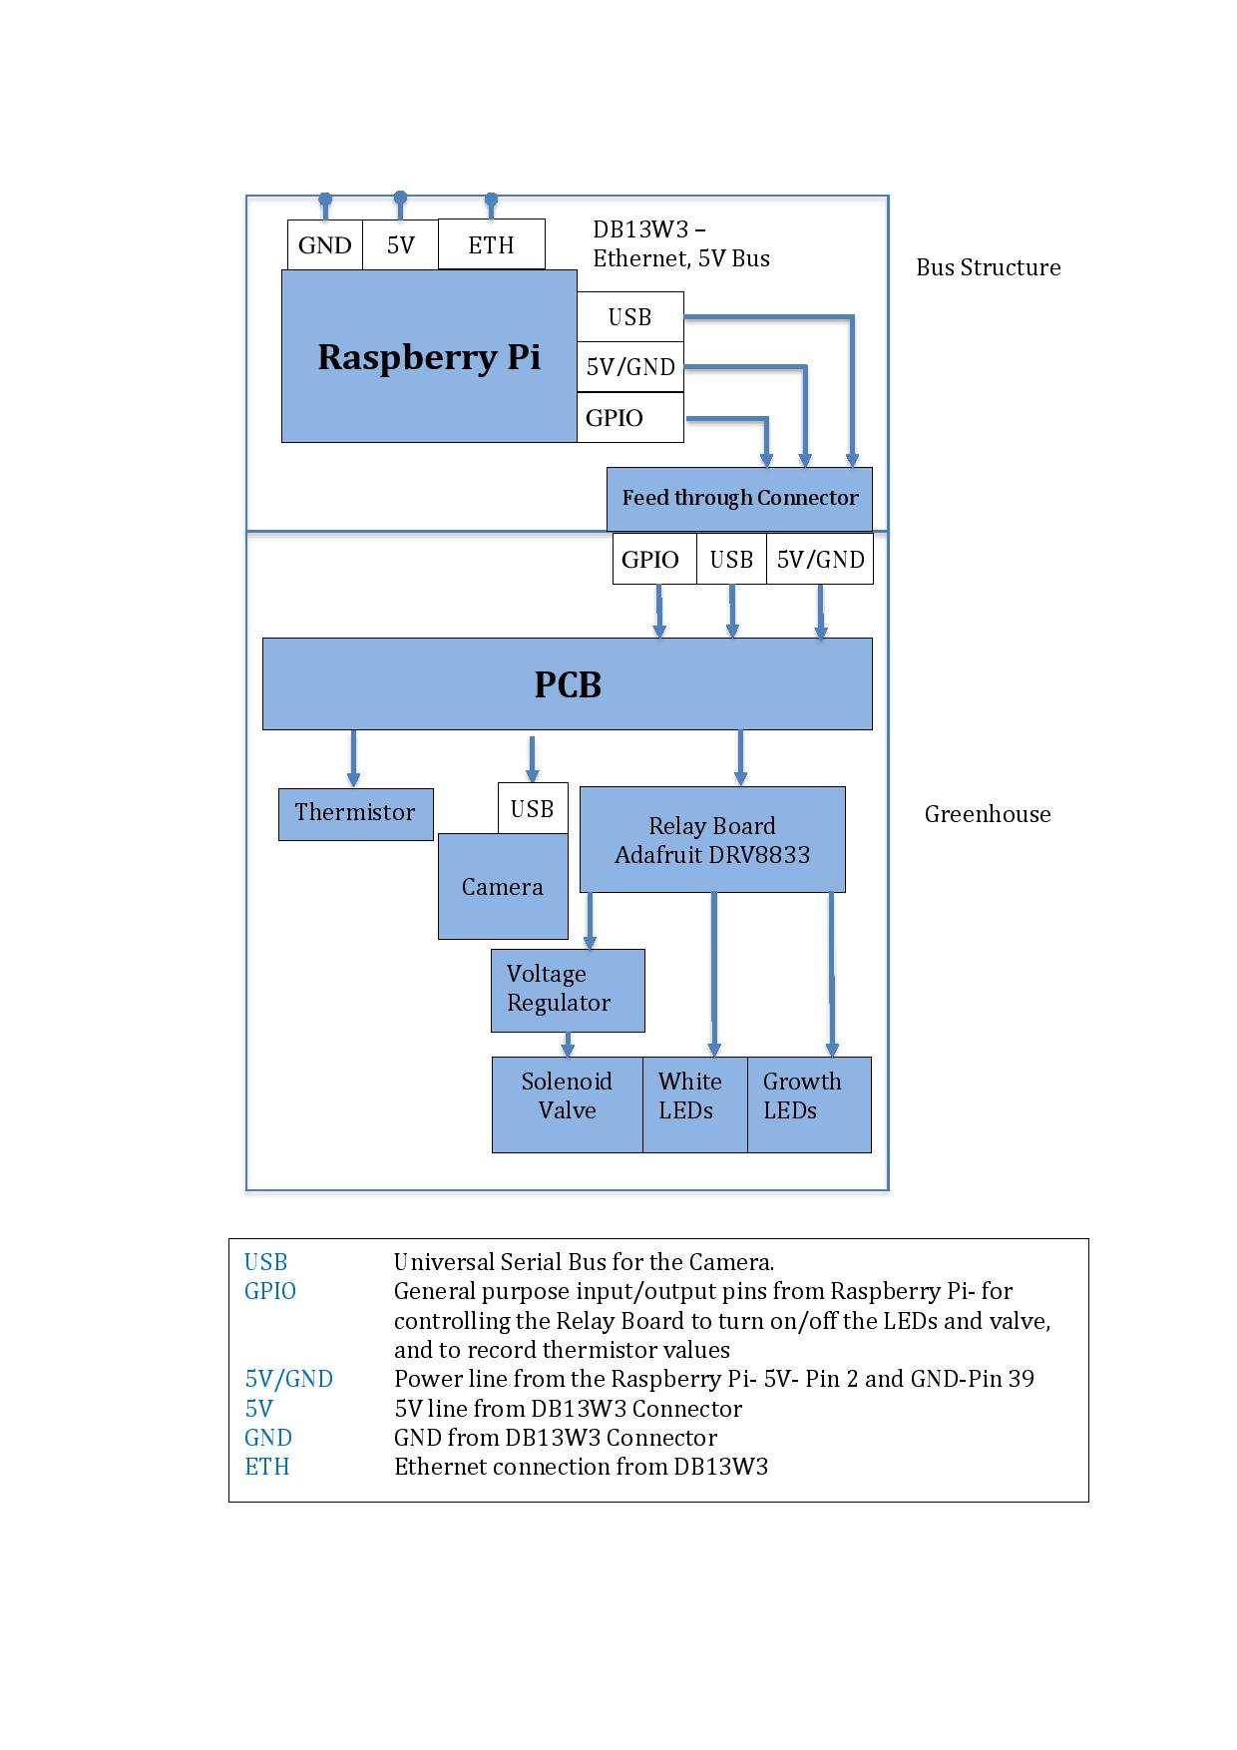

Figure 3 Hydra 1 Electronics Block Diagram

The PCB has twelve red LEDs and six blue LEDs. The blue, and a pair of red LEDs, are connected in parallel. Growth LEDs provide total of 158 PPFD, which is optimal for meeting scientific requirements for the project. There are three white LEDs connected in parallel, which are activated when the camera takes images. The logic to drive the LEDs and the valve are driven by a relay board mounted on the PCB. The relay board activates each component based on inputs received from the Raspberry Pi by supplying +5 V to each component. The solenoid valve requires 3.3 V therefore the +5V output of the relay board is converted using a 5 V to 3.3 V voltage converter. The electronics also contains a thermistor to record the temperature inside the cube, the temperature readings from the sensor are indicated in plot below. The temperature sensor was located on the PCB which was at a higher temperature because of heat generated by growth lights and sure to insulation from epoxy coating. The camera wiring harness is developed by the team, and differential pair along with power and GND (ground) are insulated using standard aluminum mesh, and polypropylene heat shrink.

Figure 4 Hydra 1 Flight Data

### Power budget

The cube was connected to the 5V power rail of the ICF. This rail can provide a maximum of 5W of power. The power budget for the experiment is summarized below:

|  |  |  |  |  |
| --- | --- | --- | --- | --- |
| Sno. | Component | Voltage (V) | Current (A) | Power |
| 1 | Raspberry Pi | 5 | 0.25 | 1.25 |
| 2 | Camera | 5 | 0.25 | 1.25 |
| 3 | Growth LEDs | 5 | 0.2 | 1 |
| 4 | White LED | 5 | 0.1 | 0.5 |
| 5 | Valve | 5 | 0.15 | 0.75 |
| Total | | | | 4,75 |

## Software Description

The operating system of the payload computer is Raspbian Jessie lite. Flight software is designed in Python and software is started at the boot up. Shell scripts are written to activate different functions of the code. These excitable shell scripts are stored in the /usr/bin folder, which can be directly called by the user in command prompt. The commands and their associated functionalities are summarized below:

*ActivateGrowthLED:* This command turns on the growth LEDs and records activation in a time- stamped text file.

*ActivateValve:* This command turns on the valve and records the activation in a time-stamped folder.

*DeactivateValve:* This command turns off the valve. This command only works when the valve is activated. This command record a time -tamped log of valve deactivation in a text file.

*ActivateWhiteLED:* This command turns on white LEDs and records a time-stamped log of white LED activation in text file.

*CaptureImage:* This command turns on the white LEDs and captures an image. The command stores time-stamped image in the respective folder. It also updates the manual image capture log. The captured images are 2592 x 1944 pixels’ in resolution and are around 8 Mbs in size.

*StopGrowthLED:* This command turns off the growth LEDs and will work only if growth LEDs are turned on. It updates the time-stamped log of growth LED deactivation in a text file.

*StopWhiteLED:* This command turns off the white LEDs. This command will only work if the white LEDs are turned on using command ‘ActivateWhiteLED’. Records a time-stamped log of white LED activation in a text file.

*ActivateHydra1:* This command automates the process for Hydra-1 image capture and growth LED activation, it turns on growth LEDs for around 4 hours. After 4 hours, software turns off the growth LEDs, and activates white LEDs and captures and stores a time-stamped image. Once this command is executed, it can only be stopped with system reboot. The size and resolution of captured images is same as in manual image capture.

The software sets the brightness of the LEDs by reading the value from a text file. To reduce the brightness, the contents of the text file are changed which allows the brightness to be reduced or increased. The brightness is increased or decreased based on Pulse Width Modulation, which controls the power delivered to the LED. However, the maximum brightness of the LEDs is determined by the current passing through it. This is controlled by resistors connected in series to the LED and hence max brightness is hardware limited.

A system service in Python is also created to read the temperature value every two minutes and store the time-stamped values in a text file. This service is automatic and does not require user input to start. The service starts as soon as the Raspberry Pi is booted up. However, this service can be stopped and restarted at any time using user commands.

## Software configuration and installation procedure

This section contains detailed instructions to install and configure the flight software in raspberry Pi.

1. Go to the folder /home/pi
2. Create the following folders and sub folders
3. Place the Code file named Hydra1.py, Hydra1Temp.py, Hydra1.sh and Hydra1temp.sh in the folder /home/pi/Hydra1/Code

Figure 5Folder and subfolders to store data and log files

1. The images taken by “*ActivateHydra1*” command are stored in /home/pi/Hydra1/AutomaticImageCapture
2. The folder /home/pi/Hydra1/LEDConfiguration contains two .txt files containing the desired brightness of the white and Growth LEDs
3. The image files generated using “*CaptureImage*” command are stored in /home/pi/ManualImagecapture
4. /home/pi/Hydra1log folder contains all the logs of the system such as:
   * Temperature date
   * Time stamped log of a command execution, which gives the user ability to track which and when an electronic equipment was turned on or off
   * Time stamped log of programming errors
5. The log of ActivateHydra1 command is stored in two subfolders of /home/pi/Hydra1Log/Automatic. The image capture log is stored in /home/pi/Hydra1Log/AutomaticImageCapture, and activation and deactivation of growth LEDs is stored in /home/pi/Hydra1Log/Automatic/GrowthLED
6. The log for Growth LED activation via command “ActivateGrowthLED” and “StopGrowthLED” is stored in /home/pi/Hydra1Log/GrowthLED
7. The log for temperature date are stored in /home/pi/Hydra1Log/TemperatureLog
8. The log for valve activation and deactivation are stored in /home/pi/Hydra1Log/Valve
9. The log for white LEDs activation and deactivation are stored in /home/pi/Hydra1Log/WhiteLED.
10. The log for software error such as execution error etc are stored in /home/pi/Hydra1Log/TryCatch
11. Place the executable files titled the following in folder /home/pi. Each file corresponds to a software command.
    * ActivateGrowthLED
    * ActivateWhiteLED
    * ActivateHydra1
    * ActivateValve
    * CaptureImage
    * DeactivateValve
    * StopGrowthLED
    * StopWhiteLED
12. After creating the aforementioned folders and placing the right programming files in the respective folder, the privileges for each files has to be set.
    * sudo  chmod +x ActivateGrowthLED
    * sudo  chmod +x ActivateWhiteLED
    * sudo  chmod +x ActivateHydra1
    * sudo  chmod +x ActivateValve
    * sudo  chmod +x CaptureImage
    * sudo  chmod +x DeactivateValve
    * sudo  chmod +x StopGrowthLED
    * sudo  chmod +x StopWhiteLED
13. Move all the files in step 14 to folder /usr/bin
    * sudo mv ActivateGrowthLED /usr/bin
    * sudo mv ActivateWhiteLED /usr/bin
    * sudo mv ActivateHydra1 /usr/bin
    * sudo mv ActivateValve /usr/bin
    * sudo mv CaptureImage /usr/bin
    * sudo mv DeactivateValve /usr/bin
    * sudo mv StopGrowthLED /usr/bin
    * sudo mv StopWhiteLED /usr/bin
14. Move a system service file named Hydra1Temp.service to /etc/system/system. This script will start running the script for reading temperature data as soon as OBC is started
    * sudo mv Hydra1Temp.service /etc/system/system
15. Change the permissions to the file using the following command
    * sudo chmod 664 /etc/system/system/Hydra1Temp.service
16. Activate the temperature sensor service using the following commands:
    * sudo systemctl daemon-reload
    * sudo systemctl start Hydra1Temp.service
    * sudo systemctl enable Hydra1Temp.service
    * Sudo systemctl start Hydra1Temp.service
17. Open crontab and add the following line:
    * @reboot /home/pi/Hydra1/Code/Hydra1.sh

## Qualification Testing

Various qualifications tests were performed on the flight cube to ensure that it meets design requirements for the mission by exposing it to various anticipated environments to assure its operational suitability.

### Vibration testing

The vibration testing of Hydra-1 was carried out at TU Graz on 18 March 2018. The test included natural frequency survey, random vibration (60 s) and was followed by a natural frequency survey on each axis. The Hydra-1 Cube was installed in a 2U Test Pod for all environmental test exposures. The Test Pod was installed in the +Z position. The Test Pod was secured to the shaker slip table via eight mechanical interface fixtures including a facility control sensor. Response sensors were attached to the Test Pod. The Hydra-1 cube was rotated inside the Test Pod to allow environmental testing on X/YZ axis. The natural frequency was determined both before and after a random vibrations profile of 2.55 G RMS, 7.66 G peak accelerations, 120 mm/s RMS, 360mm/s peak velocity, and 0.7 mm RMS, 4.1 mm peak displacement. The tests observed acceptable changes in natural frequency, as shown in table below, on all axis, and complied with test requirements.

|  |  |  |  |
| --- | --- | --- | --- |
| Natural Frequency Survey | X Axis | Y Axis | Z Axis |
| Before Random Vibrations | 538.95Hz | 531.12Hz | 227.28Hz |
| After Random Vibrations | 534.24Hz | 528.02Hz | 230.63Hz |

Detailed visual inspection conducted on the cube and functional tests confirmed that the experiment cube suffered no damages because of testing. The vibration test of the chamber with the seeds loaded was conducted on 4 June 4, 2018 at NASA Ames and the seed cassette was visually inspected afterward, and 100% of the seeds remained in place.

### Vacuum testing

As part of qualification testing, Hydra-1 was exposed to vacuum for one hour. Functionality tests were conducted before and after the vacuum testing as an evaluation of the payload. The cube passed the vibration testing criteria.

### Interface Testing with ICE Cubes

Interface tests were performed between Hydra-1 proto Flight Model and ICF engineering model, and its respective ground terminal. The detailed check consisted of visual inspection, physical and electrical checks, and communication checks between Hydra-1 cube installed on the ICF EM model and ground station used for Hydra-1. The cube was compliant with design and interface requirements document.

## Experiment Operations

Hydra-1 was installed in the ICE Cubes Facility in the Columbus module aboard the International Space Station on 13 December 2018. The Hydra-1 Ground Terminal has direct access to the payload via a VPN setup by ICE Cubes ground terminal. Experiment operations can be classified in to three broader categories which includes the initial check out, activation, and normal operations.

### Initial Check Out

This phase includes turning on all the components except the valve and establishing their functionality. This stage is important to be performed after the experiment is installed in facility and after every reboot to ensure functionality of all the components.

### Experiment activation

This is second phase of the operations which including releasing the water and nutrients by activation of the valve, then commanding to OBC to activate an automated script on board. This activates the growth LEDs, and the camera will take an image after every 4 hours and store it. In addition to image files, the automated script also takes time-stamped activation and deactivation of individual components in log files.

### Normal Operations

These operations require the download of images and log files generated by the experiment. These commands are sent by the ground terminal to synchronize the folders on the OBC with the ground terminal. Every day the payload operations engineer will go through the log files and ensure that the experiment is running smoothly.

## Operational challenges

There were no major operational challenges during the mission. There were a few issues encountered during the mission, which are listed below but the events did not have any major impact on the science.

### Releasing water in space, issues and way around

ISU conducted some tests in regards to water delivery on ground and it was discovered that at the start of water delivery, backpressure is created, which results in creation of some droplets around the edges of seed cassette.  The presence of the backpressure along with various other factors such as absorption rate of filter paper/cheese cloth with respect to water flow rate, etc., can potentially result in a stream of droplets or a jet of water being released in to the chamber which can short the electronics, block the camera view or similar. This resulted in change in operations pertaining to water delivery in space and it was decided that, water plus nutrients to be delivered in seven stages. All the seven stages of water delivery were recorded on video, and images were taken before and after each stage of water delivery. The seven stages can be subdivided as following:

* First stage will be of initial burst of water for two seconds.
* Next six stages will be two-second water bursts with 30 seconds delay in between.

### Power outages during the mission

There was two power outage of fifteen minutes on 27 December 2018 between 11:28 - 11:40 GMT and on 5 January 2019 between 14:35 to 15:10 GMT, during the mission. These resulted in an ICF software crash, so communications with the payload were lost. As a consequence, the ICF facility was rebooted which resulted in Hydra-1 Cube reboot. The 15 minutes’ and 35-minute outage did not have any impact on the science because plants are normally exposed to light/dark cycles in nature.

# Bibliography

ICE Cubes Team, 2019. *ICE Cubes.* [En ligne]   
Available at: http://www.icecubesservice.com/wp-content/uploads/2019/04/ICU-SA-RQ-004_1.5.0-ICE-Cubes-Facility-to-Experiment-Cube-IRD.pdf  
[Accès le 18 August 2019].

# Appendix: Software test Procedure

|  |  |  |  |  |  |  |
| --- | --- | --- | --- | --- | --- | --- |
| **Test Case Design Information** | | | **Test case Execution Information** | | | |
| **Test Case Number** | **Level** | **Author** | **Pass/Fail** | **Date/ Time Tested** | **Tester** | **Version Number** |
| Hydra1-Testcase-101 | Critical | YS Dhillon |  |  |  | N/A |

**1. Objective:**

This test has the following objectives:

* Verify the functionality of Hydra 1 OS and check if it is running properly
* Verify the functionality of all software modes
* Verify the functionality of the valve
* Verify the functionality of growth LEDs and white LEDs

**2. Pre-Conditions:**

This test is performed to check if the electrical systems for Hydra 1 payload. The test will also ensure the functionality of all components before conformal coating.

**3. Requirements:**

N/A

**4. Input:**

Raspberry Pi should be connected to a power cord. Raspberry pi will be connected to a laptop using Ethernet cable.

## 5. Test Setup:

Figure 1 represents the hardware setup for the test. The laptop will be connected to the raspberry pi through an Ethernet cable. All the functionalities of the cube are to be tested using the Ethernet connection. The feed going into the Container lid from raspberry pi is divided in to two parts:

1. USB cable - which provides the power for inside of the cube and the data lines for the camera.
2. 5 wires that are connected to the header of the raspberry pi, that serve as activation lines for Growth LEDs, White LEDs, Valve and the temperature sensor.

Aforementioned connections are established between Raspberry pi and PCB using a hermetically sealed connector in the lid. The growth LEDs, white LEDs are soldered directly on the PCB, and valve is soldered on the PCB through PTFE coated wires. Camera is connected to the PCB using a connector.

Container Lid

Raspberry Pi

Camera

PCB

Valve

Laptop

Figure 6 Block Diagram of Hydra 1 Electrical System

## 6. Test Steps/ Observations:

|  |  |  |
| --- | --- | --- |
| Step | Steps | Pass/Fail |
| 1 | Start Putty on the computer |  |
| 2 | Insert the I.P. address of the cube or the host name  IP- to be determined by tester or  hostname: raspberrypi  Enter port as 22. |  |
| 3 | Click on open |  |
| 4 | Enter username : pi  Enter password : Hydra1 |  |
| 5 | Type sudo bash |  |
| 6 | Type *ActivateGrowthLED*  The growth LEDs will be turned on. Ensure that all the LEDs are turned on  12 Red and 6 Blue.  Wait for LEDs to be turned off (20 seconds), before typing next command |  |
| 7 | Type *ActivateWhiteLED*  White LEDs will come on. Ensure that 3 White LEDs are on. |  |
| 8 | Type *StopWhiteLED*  This command will turn-off the white LED. Ensure that the white LEDs are turned off. |  |
| 9 | Type *ActivateValve*  This command will activate the valve. As the valve is activated, a click sound is observed.  Another way to test if the valve opened is to connect the tubing and release the water by applying pressure on the water bag. |  |
| 10 | Type *DeactivateValve*  This command deactivates the valve. |  |
| 11 | Go to home directory, type  *cd /home/pi* |  |
| 12 | Type *ls -lh*  This command enlists all the files present in the directory. If you jpg files present, the following  *sudo rm –f *.jpg*  this command deletes all the jpg files.  *type ls –lh*  the jpg files should not be observed now. |  |
| 13 | Type  *fswebcam ImageTest1.jpg*  The command uses fswebcam library and clciks an image |  |
| 14 | Type *ls –lh*  An image titled ImageTest1.jpg, should be present in the directory. This ensures that the camera is working fine. |  |
| 15 | Remove the the jpg files just created. Type  *sudo rm –f *jpg* |  |
| 16 | Type *sudo date*  Record the date and time. |  |
| 17 | Type  *CaptureImage*  This command activates the white LEDs and clicks and saves a time stamped image. |  |
| 18. | Type *cd /Hydra1/ ManaualImageCapture*  This command will change the directory to the directory where manually captured images are stored |  |
| 19 | Type *ls –lh*  Based on the noted time above, observe if a non-empty time stamped .png file is present inside the folder. If the file is present, that ensures that all the functionalities of cube are working.  If the ls-lh results in an empty files, this would imply that the CaptureImage command did not work.  Type *CaptureImage*  Type *ls-lh* and observe if the new file is created. |  |
| 20 | Return to home directory  Type cd..  Type cd .. |  |
| 21 | Type cd /Hydra1Log/TempratureLog |  |
| 22 | Type ls –lh  This will enlist all the temperature log files. Based on Test’s date- recorded in point 16, open the relevant file. |  |
| 23 | To open a particular file, following commands are used  sudo nano <filename.txt>  insert the relevant file name in command above. Check if the all the temperature data is present. |  |
| 24 | Power off raspberry pi  Type *sudo poweroff* |  |
| 25 | Repeat the steps above for other PCBs |  |

## 7. Observations:

Insert the observations here, if a particular point is failed for a PCB – it should be enlisted here

## 8. Expected Results:

All the components for the PCB work.

## 9. Results:

## 10. Comments/Feedback